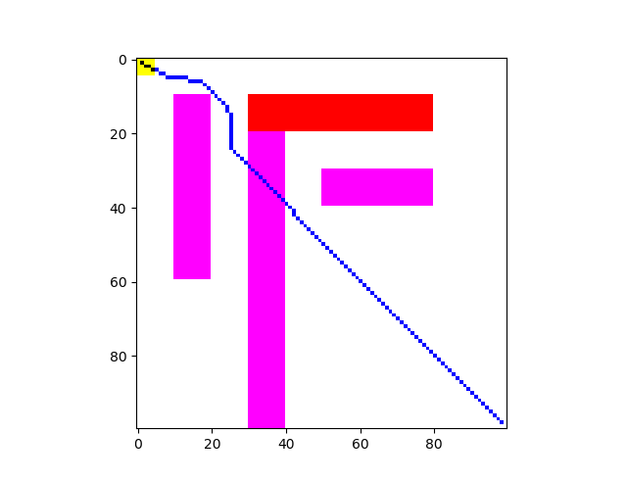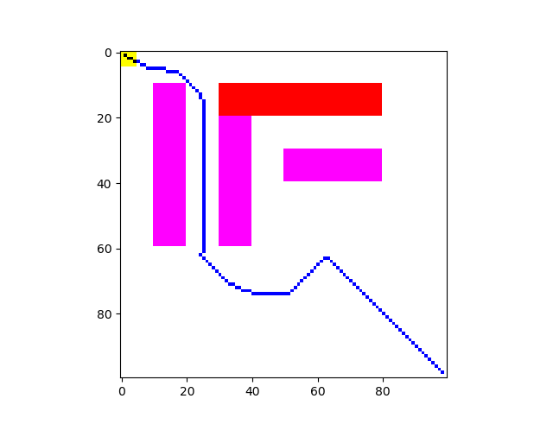The choice of these two environment is to test if the method gives a route that bypasses too much obstacles (in Env3). For purple obstacles, the diffusion factor is set to 0.2. The results are as following:

Figure Env3r

Figure Env4r

In fact, the route chosen in this method is not the optimum in the sense of distance.